**Title:**

*The Physics of Whale Movement: Swimming Performance and Propulsive Efficiency of Free-Swimming Baleen Whales*

**Authors and Affiliations:**

Hayden J. Smith1, William T. Gough2, Mathew S. Savoca2, Max F. Czapanskiy2, Frank E. Fish3, Jean Potvin4, K.C. Bierlich5, David Cade*6*, John Kennedy4, Jeremy A. Goldbogen2

1Southwestern University, 2Stanford University, 3West Chester University, 4Saint Louis University, 5Duke University, 6University of California Santa Cruz

**Abstract:**

Mysticete (baleen) whales comprise some of the largest swimming animals that have ever evolved on earth and, as a result, present an ideal case study for examining how morphology and the kinematics of swimming scale up to the largest body sizes. The current study uses data from inertial whale-borne sensors coupled with morphometric measurements from UAV drones to calculate kinematic parameters related to oscillatory swimming for three whale species (minke, humpback, blue) ranging in size from ~9-25m. These data have allowed us to produce the first estimates of thrust power, drag coefficient, Reynolds numbers, and propulsive efficiency for swimming baleen whales. Our results show that mass-specific thrust increases with increasing swim efforts but is unaffected by body size or tail area. Our data also shows that propulsive efficiency increases with increasing swim speed but decreases with increasing body size, contrary to previous estimates for smaller animals that propulsive efficiency should increase with increasing body size. We also compared our empirically-parameterized estimates to a rigid-body model and found that the drag for a swimming animal is ~3-6 times higher than the simple gliding model. The relationships between kinematics, morphometrics, and hydrodynamic performance that we have shown for these massive animals ultimately confirm that oscillatory swimming remains an effective and efficient swimming mode, regardless of body size. Together with previous studies of smaller animals, our results could help us understand why this particular swimming style has proliferated so widely and remained relatively conserved over the evolutionary history of swimming.

**Introduction:**

The re-invasion of aquatic and marine environments by cetacean (whale) ancestors has resulted in a host of unique morphological adaptations that facilitate life in water. Among these is the evolution of a fusiform body shape and flattened control surfaces to move more effectively through the water (Fish et al., 2008). These morphological adaptations are functionally convergent with similar structures in other swimming animals such as thunniform fish, sharks, sirenians, and the extinct ichthyosaurs (Donley et al., 2004; Gleiss et al., 2011). The majority of these swimmers use an oscillatory swimming style that involves side-to-side or up-and-down movement of a tail to generate lift and thrust and overcome drag (any Frank citation(s) should work here). What makes mysticete (baleen) cetaceans unique among oscillatory swimmers is their enormous body sizes, which they have evolved rapidly in the last five million years (Slater et al 2017 Proc B). Because of their size and the similarity of their body shape and swimming method to other aquatic and marine animals, baleen whales present an ideal system to study how swimming performance variables scale with extreme body size.

The three whale species in our study – the Antarctic minke whale (*Balaenoptera bonaerensis*; Burmeister, 1867), humpback whale (*Megaptera novaeangliae*; Borowski, 1781 ), and blue whale (*Balaenoptera musculus*; Linnaeus, 1758) – tend to have similar life histories and behaviors but range from ~9m in length for the minke whale up to ~25 for an adult blue whale (Goldbogen et al., 2020 (scaling paper)). Finer-scale morphological differences are also present between these species, with the most prominent being the enlarged flukes and flippers of the humpback whale relative to body size (Fish and Battle, 1995). Scaling studies among baleen whales allow us to dissect how dissimilar body size and morphology interact and affect swimming kinematics and hydrodynamic performance.

Cetacean swimming performance has been studied to understand important morphological differences that affect swimming kinematics, behavior and ecology (Fish, 1993a; Curren et al. 1994, Fish 1998). However, these studies focused on unsteady maximum speed measurements of smaller and highly maneuverable odontocete species in captivity (Fish, 1993; Fish, 1998). In fact, most work on cetaceans and other swimming animals has historically been conducted in a laboratory setting due to the logistical and technological constraints of working in uncontrolled aquatic or marine environments. (Edel and Winn, 1978; Fish, 2002; Fish, 2006; Potvin et al., 2009; Fish et al., 2018). However, recent technological advances are finally allowing us to study these animals *in situ* using remote sensing biologgers that allow for the measurement of uncontrolled behavior as well as the surrounding ecological context (Johnson, 2011; Goldbogen et al., 2017). Additionally, unmanned aircraft vehicles (UAV) are especially useful for classifying the demographic and health status of marine mammals (Christiansen et al., 2016; Johnston, 2019). When used in concert, biologging devices and UAV drones can complement each other and allow us to answer a wide range of questions related to the fundamental biology of cryptic species such as marine mammals in their natural habitats (Jones et al., 2006; Chambot & Bird, 2015; Johnston, 2019).

Here, we use Custom Animal Tracking Solutions (CATS) tags and UAS measures to calculate thrust power, drag coefficients, Reynolds numbers, and propulsive efficiencies for free-swimming whales. Previous studies have estimated the propulsive efficiency of swimming for odontocetes and other swimming animals to be approximately ~75-85% (Fish, 1998), but the upper end of the body size range remain unstudied. This information on large whales will provide insight into the evolution of body shapes for whales and other oscillatory swimmers and will improve our understanding of baleen whale energetic efficiency (Gough et al., 2019; Goldbogen et al. 2019 Science scaling peper). Propulsive efficiency is typically defined as the percentage of locomotive energy that is successfully transferred into useful work and forward thrust (Chopra and Kambe, 1977; Fish, 1993). A propulsive efficiency of >80% for these large whales would fill in our knowledge gap for the extreme upper end of body size and support the idea that oscillatory swimming is one of the most energetically efficient swimming modes for animals of any size that are required to swim rapidly or travel long distances.

**Methods:**

*CATS Tags and UAV Technology*

The CATS camera tags (Figure 1s) integrate video (1280 x 720p resolution, 25-30 frames per second) with 800 Hz accelerometers and gyroscopes; 100 Hz magnetometers, pressure and temperature sensors; a 20 Hz internal temperature sensor; and 10 Hz light and GPS sensors. Videos were recorded in 1280 x 720p HD resolution at between 25 and 30 frames per second. Tags were deployed from 6 m rigid hull inflatable boats using a 6 m carbon-fiber pole. Tags were attached to the animal with four suction cups, detached after suction failed, floated to the surface and were recovered via VHF telemetry. Deployment lengths in this study ranged from 8 minutes to 26 hours (Cade et al., 2016). For more information on the tags used in this study, see Goldbogen et al. (2017).

Aerial drone photography was used to determine total animal body length, maximum body diameter, fluke chord length, and fluke area (Figure 2). Photographs were calibrated and length was determined by multiplying the number of pixels by the ground sampling distance (GSD) (Fearnbach et al., 2012).

(1)

(2)

with *L, npix*, *a*, *lfoc*, *Sw*, and *Pw* corresponding to total length of the animal (m), number of pixels, altitude (m), focal length (mm), width of sensor size (mm), and width of the image resolution in pixels, respectively. The width was used for the sensor size and image resolution because the whales were captured full frame widthwise (Gough et al., 2019).

*Morphometric Measurements*

Using ImageJ, the scale was set by creating a straight line from the notch in the middle of the fluke to the tip of the nose and entering the total length as the known distance. The fluke area was calculated by carefully drawing a polygonal outline of the fluke to measure the area. Chord length was measured by drawing a straight line from the notch in the fluke to the top of the fluke (not the peduncle). Body mass was estimated from total body length using regressions given by Kahane-Rapport (2018). Body surface area estimated from total body length using data provided by Fish (pers. comm).

*Mathematical Calculations*

We digitized models from Chopra and Kambe (1976) to find the essential parameters needed for our swimming kinematic calculations and to obtain numerical relationships for the reduced frequency (:

(3)

where ω is equal to the radian frequency of the motion (equal to 2π*f*, where *f* is the frequency in Hz), *C* is the wing chord, and *U* is swimming velocity (m s-1). Then we calculated (), the proportional feathering parameter:

(4)

which is the ratio of the maximum angle the wing makes with the direction of motion and the maximum angle (*ωh1/U*) achieved by the trajectory of the pitching axis of the flukes (Yates, 1983). The coefficient of thrust ( is given by:

(5)

where is equal to the total mean thrust, is the density of seawater, is the fluke area, and is the heaving amplitude. The efficiency ( is given by:

(6)

where is the mean rate of oscillation (Chopra and Kambe, 1976, Yates, 1983, Fish, 1998).

We used a customized MATLAB script to detect flukebeats based upon methods defined by Gough et al. (2019). For each detected tailbeat, we combined values from the digitizing of Chopra and Kambe’s figures, kinematic variables from the tag data such as swimming speed (*U*) in m s-1 and fluking frequency (*f*) in Hz, and UAV-measured morphometrics to calculate thrust power output, drag coefficient, and Reynolds number for the period of time corresponding to a single tailbeat. The thrust power output (*PT*) is given by:

(7)

where *ρ* is the density of seawater, *C­T* is the coefficient of thrust, *U* is swimming velocity (m s-1), *Fa* is the planar surface area of the fluke (m2), *h* is amplitude of heave (m), and *C* is the chord length (m). The equation for the dimensionless drag coefficient (*CD*) is given by:

(8)

where *Sa* is equal to the surface area of the body (*m2*). The dimensionless Reynolds number (*Re*) is defined by:

(9)

where *L* is the individual’s total length (m) and *v* is the kinematic viscosity of sea water. Propulsive efficiency was calculated through digitation of images in Chopra and Kambe 1976.

*Normal vs. Maximum Effort Swimming*

The relationship between normal and maximum effort swimming can be analyzed where normal effort swimming was defined as steady-state migratory swimming behaviors or swimming in between foraging events. Maximum effort swimming was defined as the period within ten seconds before a lunge feeding event. This punctuality was chosen because at this point during the lunge, we can compare measurements of absolute performance by looking at the same swimming velocities and compare relative kinematics at that specific speed. Once identified, normal swimming kinematics and maximum swimming kinematics were sorted from one another to be individually analyzed and compared.

*Comparison to a Simple Rigid-Body Model*

We created a simple rigid-body model comparison for our data using an equation devised by Hoerner (Hoerner, 1962; Blevins, 1983) that determines the relationship between drag coefficient and Reynolds number for a simple gliding body of a given shape. Hoerner’s equation for drag force can be found by first solving for the drag coefficient with respect to time (*CD*(*t*)) which is given by:

(10)

where is equal to the correction factor for an undulating body (1 for rigid-body simulations), is the animal’s body length (m), is the swimming speed (m s-1) with respect to time, is the kinematic viscosity, and is the maximum body diameter (m). We can then plug the resultant into the equation for drag force () which is given by:

(11)

where is the mass density of seawater and is the wetted body area which is approximated using body mass (Fish, 1993).

We plotted drag coefficient vs. Reynolds number for the simple Hoerner model predictions with our real, empirical estimates of heaving, full body animals. This permitted us to examine the comparison of drag on a rigid, gliding body with no appendages to the drag on a swimming animal with morphological features and control surfaces present.

*Statistical Analyses*

We investigated intra-and-interspecific relationships between and among the animals (n=63) in the study. We compared hydrodynamic performance variables (thrust power output, drag coefficient, Reynolds number, propulsive efficiency) and morphometric measurements using R and RStudio (Version 1.2.1335, packages: ggplot2, ggpubr, and tidyverse). Generalized linear mixed-effects models (GLMMs) were created using the mean mass-specific thrust for normal effort swimming speed (m s-1) (Figure 3). Linear fit regressions were performed for the thrust figures (Figures 3, 4, and 5), drag figures (Figure 6), and propulsive efficiency figure (Figure 7). GLMMs for propulsive efficiency (Figure 6) depending on normal effort swimming speed (m s-1) and total body length (m) were constructed with identical details and parameters as Figure 3.

**Results:**

The species-level means (± se) for each of our measured kinematics variables and morphometrics are given in Table 1. The species-level means (± se) for each of our measured hydrodynamic parameters are given in Table 2.

Figure 3 shows that mean mass-specific thrust is constant at increasing body size and increases linearly as swimming speed increases. Figure 4 shows mean mass-specific thrust against total body length (m) at both normal and maximum effort swimming. Both effort levels show slight visual increases with increasing body size but only normal effort was found to be significant (Table 3). At any given body size, the mean-mass specific thrust increased with the transition from normal to maximum effort swimming. Figure 5 shows mean mass-specific thrust against the ratio of fluke area over total body length. There was substantial scatter around the linear fit and no significant relationship (Table 3).

Figure 6 shows our empirically-derived data for drag coefficient against Reynolds number for swimming whales as well as the rigid-body model regression using the Hoerner equation. While the Hoerner model predicts a slight decrease in drag coefficient with increasing Reynolds number, we found the opposite to be true for swimming animals, with larger animals having a significantly greater drag coefficient than smaller animals.

We regressed the propulsive efficiency against swimming speed (m s-1) (Fig 7A) and total body length (m) (Fig 7B) and found that propulsive efficiency increases significantly as swimming velocity increases and decreases significantly with increasing body size.

Comparing the mean propulsive efficiencies for our three study species against other swimming animals showed that all oscillatory swimmers (mysticete cetaceans, odontocete cetaceans, tuna, manatee, pinnipeds) were highly efficient at ~80% or higher (Figure 8). Other styles of swimming were lower, with subcarangiform undulatory swimmers averaging ~75% and drag-based paddling swimmers averaging ~25%.

**Discussion:**

Many previous studies that have quantified the kinematics and hydrodynamics of cetacean swimming have been fortunate to use captive animals that can be measured reliably from a stable reference position (Fish, 1993; Fish 1998; Rohr and Fish 2004). While our methods are less precise, the sophistication of modern biologging and UAV technologies has allowed us to measure many of the same variables. Some, such as the amplitude of heave or angle of attack of the flukes relative to the body, are still beyond our reach and so we supplemented our empirical data with validated estimates for these unknown variables (Bainbridge, 1958; Fish, 1998). This combination of empirical data and strong estimates allowed us to quantify hydodynamic and kinematic aspects of mysticete swimming using many of the same methods derived by Chopra and Kambe (1977) and validated for odontocetes by Fish (1998). The similarity between our methods and those of previous studies strengthens our ability to compare between species and taxonomic groups and determine more fundamental principles of oscillatory swimming.

Thrust generation is a fundamental aspect of any swimming mode and the achievable mass-specific thrust for a swimming animal has a direct impact on its maximum swimming speed and, subsequently, the types and quantities of prey that it can capture (citations). For cetaceans, high mass-specific thrust allows odontocetes to capture fast-moving, individual fish (citations) and allows mysticetes to achieve high speeds during feeding lunges to offset the deceleration during prey engulfment as well as the potential escape response of different prey types (Cade et al., 2016; Cade et al., 2019; others). Fish (1998) measured the swimming speed and estimated the thrust output for four odontocete species and found that thrust increased with increasing swimming speed for all species. Additional studies surrounding odontocete swimming speed and thrust have also found a similar relationship between increasing thrust and swimming speed(Weihs, 2002). In this study, we found that the mass-specific thrust for normal fluking (at lower velocities of 1-3 m s-1) are very similar for all three species, and show similar relationships to Fish and Weihs in that thrust increases as swimming velocity increases.

Studying free-swimming animals meant that we could analyze mass-specific thrust output to a deeper level and parse out normal effort swimming from the increased effort leading up to a feeding lunge. Since both effort types were chosen to be at roughly similar speeds, we suspect that the increased thrust generation seen in Figure 4 is the result of the animal altering other kinematic variables in order to generate thrust for the upcoming lunge. High mass-specific thrust generation is more trivial at normal effort swimming because these animals are typically swimming in a way that results in the lowest energetic cost (~1.5-2.5 m s-1) and the larger animals have to use more power than the smaller (Gough et al., 2019). The similarity of the increase (~twofold) from normal to max effort thrust generation across our body size range suggests that all of our whales are preparing for a lunge in dissimilar ways. All of the species included in our study are lunge feeders, meaning they feed by opening their mouth like a parachute and engulfing a large volume of water into an expansible throat pouch (Cade et al., 2016; Cade et al., 2019). Empirical data (Cade et al., 2019) and hydrodynamic models (Potvin et al. 2009) suggest that animals begin these lunges at high speeds (3.5-5 m s-1) in order to overcome heightened drag and move through the prey patch entirely on momentum (Potvin et al., 2009; Cade et al., 2016; Cade et al., 2019). Our results give an approximation for how much thrust may be required for animals of different sizes to generate the momentum necessary to complete their feeding lunges effectively.

Focusing more heavily on the relationship between mass-specific thrust generation and body size, our results diverge slightly from previous estimates. Fish (1998) determined that mass-specific thrust and body size have no relationship, but we found that mass-specific thrust increases as body length increases. This relationship was significant for normal effort swimming, but was found to be non-significant for maximum effort swimming. The large amount of data in or dataset for normal effort swimming relative to maximum effort could explain why the relationship was significant for the former and not the latter. We expected that humpback whale might exhibit a larger mass-specific thrust that our two other study species because of their very large fluke area relative to body size. For lift-based oscillatory swimmers, thrust is produced via the combination of lift and drag forces produced by control surfaces such as the flippers and tail flukes (Goldbogen, Fish, and Potvin; 2016). Maximum thrust and high propulsive efficiency is typically achieved with a broad, semi-lunate paddle/fluke area that is attached to the body through a constricted peduncle region (Fish, 2004). We understand that there are morphological variations in rorquals across scale (Woodward et al. 2006; Kahane-Rapport & Goldbogen, 2018), but there has been minimal work relating fine-scale morphology of the control surfaces to hydrodynamic performance in large whales. Interestingly, we found that the scaled fluke length has no effect on thrust production and was very similar for all species. We think the humpback whale’s large flukes are being offset by their enlarged flippers and rotund body shape, both of which are adaptations for increased maneuverability at the potential expense of higher thrust generation (citations). Overall, our results show that thrust production on a mass-specific basis is greatest in the largest animals and scales in relation to body size and not necessarily appendage size or shape.

Drag coefficient vs. Reynolds number

In comparison to our tagged animals, Hoerner’s R-100 airship models used for computational analysis did not include control surfaces (flippers or flukes). Instead, the approximated environment around the airship was determined using wind tunnel test data (Hoerner 1962; Blevins, 1993). These modeled values suggest that for a minke whale (~9m), the drag coefficients for fluking should be roughly three times as high than non-fluking and gliding. But the difference between these coefficients should increase for larger animals, culminating in a six-fold difference for a blue whale (~22m) (Figure 6). (Hope to get Jean’s input here, too)

*Propulsive efficiency*

*Swimming velocity (m s-1)*

Findings from Fish 1998 show that the propulsive efficiency of swimming odontocetes in captivity are ~80-90% (Fish, 1998). Our goal was to determine if body size, especially at the extreme upper limits, significantly impacts this efficiency. Figure 7 shows the propulsive efficiencies of the three species in our study. We found each species follows the same trend. Namely that velocities < 1.5 m s-1 result in an efficiency less than 83%, while velocities > 1.5 m s-1 results in an efficiency between 84% and 95% with the average close to 91%. This suggests that there is an optimum velocity to swim at that maximizes propulsion.

*Total body length (m)*

In this study, propulsive efficiency directly relates to the amount of work the animal does to propel itself forward. We predicted that the blue whalewould have the greatest propulsive efficiency because of its streamlined body shape and high fineness ratio, while we predict that the minke whale has a lower propulsive efficiency due to its similar shape but lower fineness ratio. We think the humpback and its rotund body shape and low fineness ratio would have the lowest propulsive efficiency. However, we see that propulsive efficiency decreases with increasing body size among rorquals but is unaffected by other morphological parameters (See Figure 7B). We are able to understand this relationship by referencing Figures 4 and 6; a larger animal will have a slightly increased thrust generation but a greatly increased drag coefficient, resulting in a lower propulsive efficiency because they are having to expend more energy to overcome drag and achieve equivalent locomotion.

Regardless of the fine-scale difference between species of different sizes, the overall conclusion of our propulsive efficiency findings are that animals at the largest extremes of body size are all highly efficient swimmers. Oscillatory swimming has evolved as a high speed solution for all size ranges in animals. In Figure 8, we directly compare the propulsive efficiencies of oscillatory swimmers (mysticetes, odontocetes, pinnipeds, sirenians, and some species of fish), undulatory swimmers (most fish), and drag-based paddling (some fish, rodents, and humans), and we are able to see that oscillatory swimming may fluctuate at different sizes based on functional differences, but still stays over 75% efficiency. While undulatory swimmers’ efficiency resides ~ 60-75%, and drag-based swimmers’ efficiency is at merely ~ <35%. Our results help to confirm why oscillatory swimming has evolved so consistently and so often across different lineages. They also enhance our understanding of swimming at the upper extremes of body size, where small losses in efficiency could have far-reaching consequences for the energetics and continued fitness of these massive animals.

**Acknowledgments:**

A large thank you to Hopkins Marine Station of Stanford University, and specifically the Goldbogen Lab for the research housing and interactions. Thank you to the California State University Monterey Bay Research Experiences for Undergraduates (CSUMB REU) team and NSF for funding my research,

I would like to thank the Southwestern Physics Department, specifically Dr. Steven Alexander and Dr. Mark Bottorff, and Professor of Mathematics, Dr. Fumiko Futamura, and lastly, Mr. Lee Fellows.

**Competing Interests:**

We have no competing interests to report.

**Funding:**

This research was funded by the National Science Foundation in support of research experiences for undergraduates (REU). Additionally, this research was funded in part by grants from the National Science Foundation (IOS-1656691, IOS-1656676, IOS-1656656; OPP-1644209), the Office of Naval Research (N000141612477), and a Terman Fellowship from Stanford University. Additional Monterey Bay CATS tag deployments were funded by grants from the American Cetacean Society Monterey and San Francisco Bay chapters, and by the Meyers Trust. All procedures in USA were conducted under approval of the National Marine Fisheries Service (Permits 781-1824, 16163, 14809, 16111, 19116, 15271, 20430), Canada DFO SARA/MML 2010-01/SARA-106B, National Marine Sanctuaries (MULTI-2017-007) and institutional IACUC committees.

**References:**

1. Cade, D. E., Carey, N., Domenici, P., Potvin, J., and Goldbogen, J. A. (2019) Predator-informed looming stimulus experiments reveal how large filter feeding whales capture highly maneuverable forage fish. In review.
2. Cade, D.E., Friedlaender, A.S., Calambokidis, J., Goldbogen, J.A. (2016). Kinematic diversity in rorqual whale feeding mechanisms. *Curr. Biol.* **26**: 2617-2624.
3. Chambot, D., & Bird, D. M. (2015). Wildlife research and management methods in the 21st century: Where do unmanned aircraft fit in? *Journal of Unmanned Vehicle Systems*, **3**, 137-155.
4. Chopra, M. G., & Kambe, T. (1977). Hydromechanics of lunate-tail swimming propulsion. Part 2. *Journal of Fluid Mechanics*, *79*(1), 49-69.
5. Christiansen, F., Dujon, A. M., Sprogis, K. R., Arnould, J. P. Y., & Bejder, L. (2016). Non-invasive Unmanned Aerial Vehicle provides estimates of the energetic cost of reproduction in humpback whales. *Ecosphere*, **7**, e01478.
6. Curren, K. C., Bose, N., & Lien, J. (1994). Swimming kinematics of a harbor porpoise (*Phocoena phocoena*) and an Atlantic white- sided dolphin (*Lagenorhynchus acutus*). *Mar. mammal. Sci.* **10**, 485–492.

Edel, R.K. and Winn H.E. (1978). Observations on underwater locomotion and flipper movement of the humpback whale Megaptera novaeangliae. *Mar. Biol.* 48:3. 279-287.

1. Fearnbach, H., Durban, J., Parsons, K., & Claridge, D. (2012). Photographic mark–recapture analysis of local dynamics within an open population of dolphins. *Ecological Applications*, *22*(5), 1689-1700.
2. Fish, F.E. (1993). Power output and propulsive efficiency of swimming bottlenose dolphins (*Tursiops truncatus*). *J. Exp. Biol.* **185**: 179-193.
3. Fish, F.E. (1998). Comparative kinematics and hydrodynamics of odontocete cetaceans: morphological and ecological correlates with swimming performance. *J. Exp. Biol.* **201**: 2867-2877.
4. Fish, F.E. (2002). Balancing requirements for stability and maneuverability in cetaceans. *Integrative and Comparative Biology*, 42(1), 85-93.
5. Fish, F. E. 2004. Structure and mechanics of nonpiscine control surfaces. IEEE Journal of Oceanic Engineering 29(3):605-621.
6. Fish, F. E. (2006). The myth and reality of Gray's paradox: implication of dolphin drag reduction for technology. *Bioinspiration & biomimetics*, *1*(2), R17.
7. Fish, F.E., Williams, T.M., Sherman, E., Moon, Y.E., Wu, V. and Wei, T. (2018). Experimental measurement of dolphin thrust generated during a tail stand using DPIV. *Fluids.* **3**: 33.
8. Goldbogen, J.A., Cade, D.E., Boersma, A.T., Calambokidis, J., Kahane-Rapport, S.R., Segre, P.S., Stimpert, A.K. and Friedlaender, A.S. (2017). Using digital tags with integrated video and inertial sensors to study moving morphology and associated function in large aquatic vertebrates. *Anat. Rec.* **300**: 1935-1941.
9. Gough, W.T., Segre, P.S., Bierlich, KC., Cade, D. E., Potvin, J., Fish, F. E., Dale, J., di Clemente, J., Friedlaender A.S., Johnston D.W., Kahane-Rapport, S., Kennedy, J., Long J.H., Oudejans, M., Penry, G., Savoca, M.S., Simon, M., Videsen, S.K.A., Visser, F., Wiley, D.N. and J.A. Goldbogen. *In review.*Scaling of swimming performance in the largest animals.
10. Johnson, M. (2011). Measuring the orientation and movement of marine animals using inertial and magnetic sensors – a tutorial. Fine-scale animal movement workshop, Hobart, March 2011.
11. Johnston, D. W., (2019). Unoccupied Aircraft Systems in Marine Science and Conservation. *Annual Review of Marine Science*. Vol. 11:439-463.
12. Jones, G. P., Pearlstine, L. G., & Percival, H. F. (2006). An assessment of small unmanned aerial vehicles for wildlife research. *Wildlife Society Bulletin,* **34**, 750-758.

Kahane‐Rapport, S. R., & Goldbogen, J. A. (2018). Allometric scaling of morphology and engulfment capacity in rorqual whales. Journal of morphology, 279(9), 1256-1268.

1. Potvin, J., Goldbogen, J. A., & Shadwick, R. E. (2009). Passive versus active engulfment: verdict from trajectory simulations of lunge-feeding fin whales Balaenoptera physalus. Journal of the Royal Society Interface, 6(40), 1005-1025.
2. Slater G. J., Goldbogen J. A., & Pyenson N. D. (2017). Independent evolution of baleen whale gigantism linked to PlioPleistocene ocean dynamics. Proc. R. Soc. B 284
3. Weihs, D. (2002) Dynamics of Dolphin Porpoising Revisited, Integrative and Comparative Biology, Volume 42, Issue 5, Pages 1071–1078.

Woodward, B. L., Winn, J. P., & Fish, F. E. (2006). Morphological specializations of baleen whales associated with hydrodynamic performance and ecological niche. *Journal of Morphology*, *267*(11), 1284-1294.

1. Yates, G. T. (1983). Hydrodynamics of body and caudal fin propulsion. In *Fish Biomechanics* (ed. P. W. Webb and D. Weihs), pp. 177–213. New York: Praeger.

**Tables/Figures/Legends**

|  |  |  |  |  |  |  |  |  |  |  |  |
| --- | --- | --- | --- | --- | --- | --- | --- | --- | --- | --- | --- |
|  | | ***Kinematics*** | | | ***Morphometrics*** | | | | | | |
| ***Species*** | ***Number of Individuals*** | ***Swim Speed (Norm) (m s-1)*** | ***Swim Speed (Max) (m s-1)*** | ***Oscillatory Frequency (Hz)*** | ***Total Length (m)*** | ***Maximum Diameter (m)*** | ***Fineness Ratio*** | ***Wetted Surface Area (m2)*** | ***Body Mass (kg)*** | ***Chord Length (m)*** | ***Fluke Area (m2)*** |
| ***Minke*** | 14 |  |  |  | 7.30 |  |  |  |  | 0.552 | 0.766 |
| ***Humpback*** | 31 |  |  |  | 11.09 |  |  |  |  | 1.05 | 3.140 |
| ***Blue*** | 18 |  |  |  | 22.50 |  |  |  |  | 1.29 | 4.708 |

Table 1. Kinematic and morphometric variables used for modeling of hydrodynamic properties for all (n=63) individual whales in our dataset. Those with an asterisk were modeled using available data and methods in the literature. All values are given as the mean ± the standard error.

|  |  |  |  |  |
| --- | --- | --- | --- | --- |
|  | ***Hydrodynamic Calculations*** | | | |
| ***Species*** | ***Mass-Specific Thrust (N kg-1)*** | ***Drag Coefficient*** | ***Reynolds Number*** | ***Propulsive Efficiency*** |
| ***Minke*** | 0.336  ±  1.3 x 10-3 | 0.011  ±  3.8 x 10-5 | 1.71 x 107  ±  2.3 x 104 | 0.920  ±  1.4 x 10-4 |
| ***Humpback*** | 0.237  ±  1.3 x 10-3 | 0.023  ±  9.9 x 10-5 | 2.23 x 107  ±  2.7 x 104 | 0.901  ±  1.8 x 10-4 |
| ***Blue*** | 0.365  ±  2.7 x 10-3 | 0.048  ±  2.9 x10-4 | 4.64 x 107  ±  1.1 x 105 | 0.851  ±  3.1 x 10-4 |



Table 2. Results from hydrodynamic and morphometric calculations for all individuals (n=63) from each species.. All values are given as the mean of all tailbeats in a deployment ± the standard error. The drag coefficient, Reynolds number, and propulsive efficiency are dimensionless. The mean fluke area is shown in m2 and the chord length and total lengthare shown in meters.

|  |  |  |  |  |
| --- | --- | --- | --- | --- |
|  | ***GLMM equation*** | ***Estimate*** | ***P - value*** | ***R2*** |
| ***Mean Mass-Specific Thrust Power*** |  |  |  |  |
| Figure 3: Speed (m s-1) | y = 0.834x – 2.872 | 0.834 | < 0.001 | 0.79 |
| Figure 5: Fluke Area / Total Length (m) | y = 1.513x – 1.080 | 1.513 | 0.219 | 0.15 |
|  |  |  |  |  |
| ***Mean Mass-Specific Thrust Power vs. Total Length (Figure 4)*** |  |  |  |  |
| Normal Effort Swimming | y = 0.025x – 0.637 | 0.025 | 0.016 | 0.11 |
| Maximum Effort Swimming | y = 0.030x – 1.571 | 0.03 | 0.201 | 0.33 |
|  |  |  |  |  |
| ***Drag Coefficient vs. Total Length (m)***  ***(Figure 6)*** |  |  |  |  |
| Empirical (in situ calculations) | y = 0.162x – 6.115 | 0.162 | <0.001 | 0.88 |
| CFD (lab rooted calculations) | y = -0.007x – 4.940 | -0.007 | 0.131 | 0.99 |
|  |  |  |  |  |
| ***Propulsive Efficiency***  ***(Figure 7)*** |  |  |  |  |
| Speed (m s-1) | y = 0.057x + 0.766 | 0.057 | <0.001 | 0.8 |
| Total Length (m) | y = -0.005x + 0.954 | -0.005 | <0.001 | 0.51 |



Table 3. This table contains equations, estimates, R2 values, and p values from generalized linear mixed models for sequential figures 3-7.

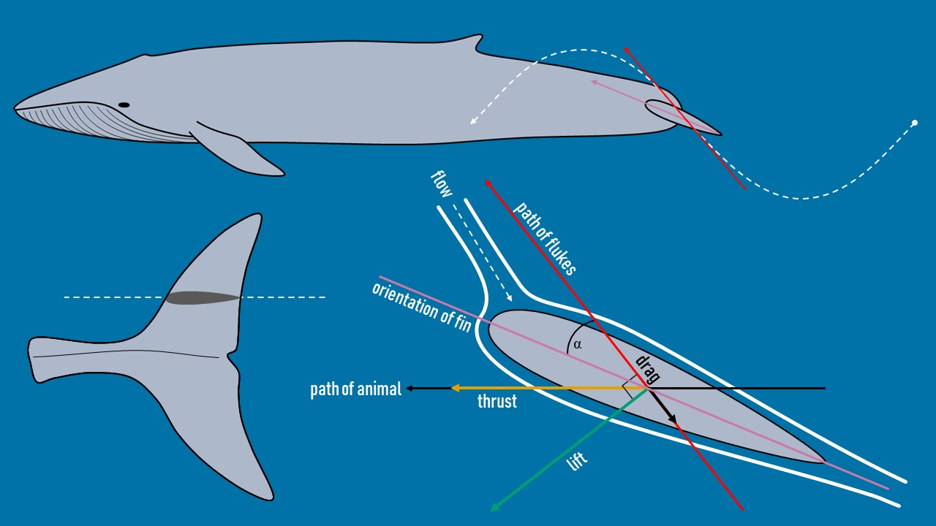

Figure 1. Adaptation from Shadwick (2005) showing the forces acting on the tail of a thunniform swimmer such as a blue whale during active oscillatory fluking of the tail. The heaving motion of the tail creates a pressure imbalance between the top and bottom faces of the fluke that results in the generation of a lift force perpendicular to the path of the flukes and a thrust force in the forward direction of travel of the animal.

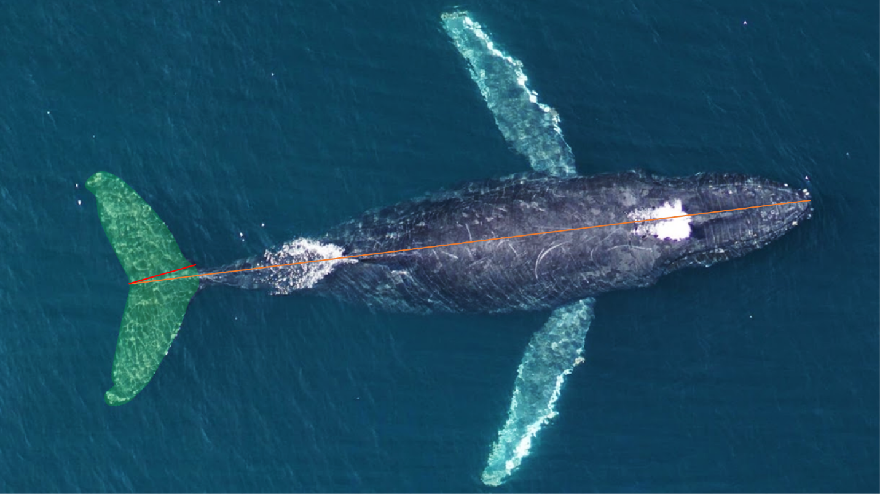Figure 2. Representative UAS drone image of a humpback whale showing the morphometric measurements taken from each animal. The orange line corresponds to the total length (in meters) from the tip of the lower jaw to the caudal midpoint of the tail. The chord length of the fluke (in meters) is denoted by the red line running from the cranial insertion of the fluke onto the peduncle to the caudal midpoint of the tail. The green shaded region corresponds to the tail area (in m2) comprising the entirety of the flukes and the peduncle region caudal to the cranial fluke insertions.

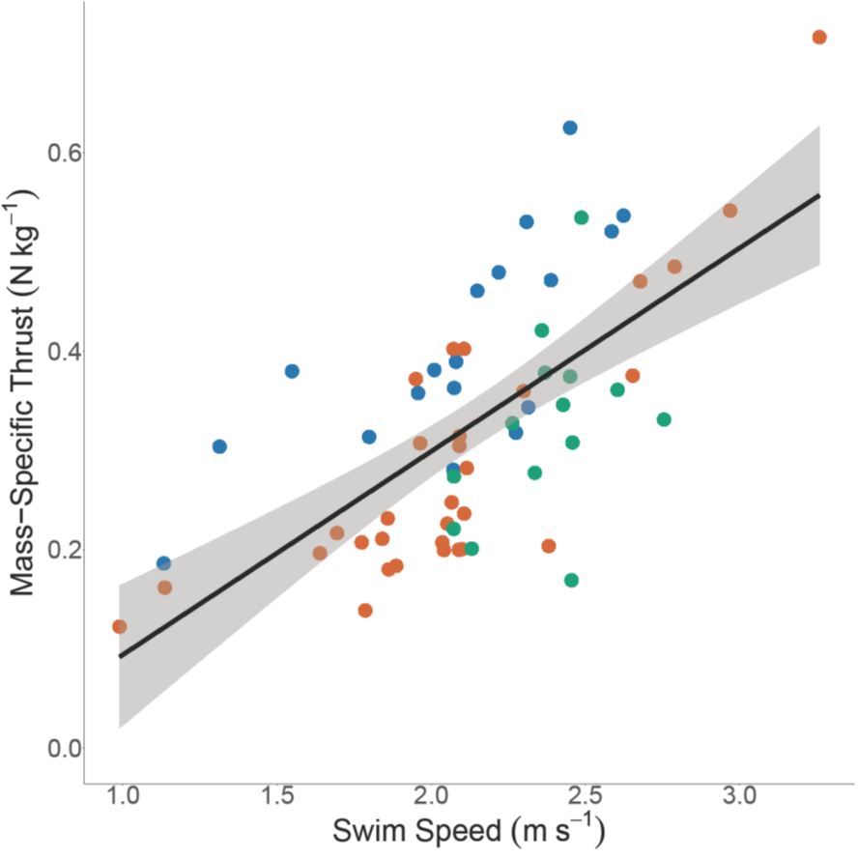

Figure 3. Linear regression of mass-specific thrust (N kg-1) versus swimming speed (m s-1). Each point corresponds to the averaged value for a single individual whale. Green points are minke whales, orange points are humpback whales, and blue points are blue whales.

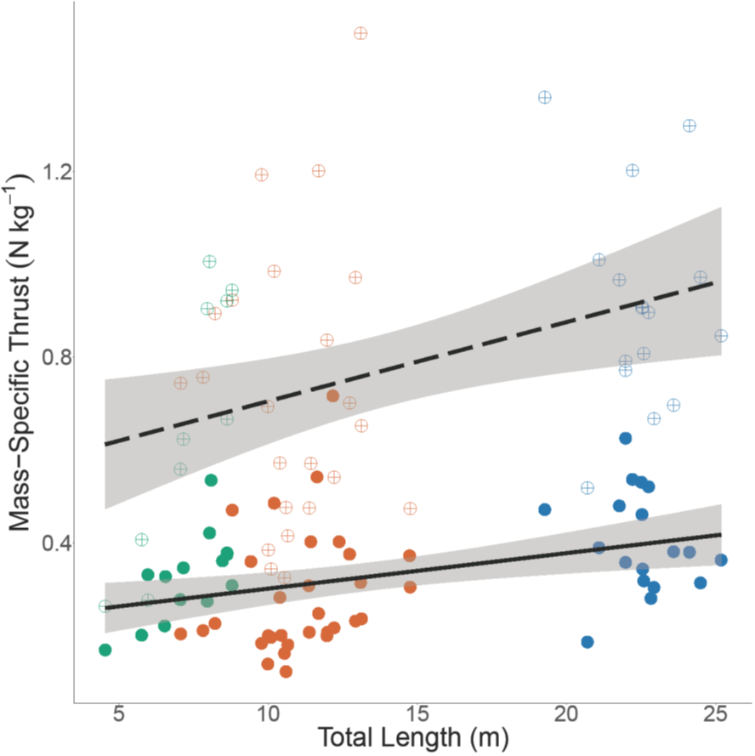

Figure 4. Linear regressions of mass-specific thrust (N kg-1) versus total body length (m) for both normal effort swimming (solid points and solid line) and maximum effort swimming (open crossed points and dotted line). Green, orange, and blue points correspond to minke, humpback, and blue whales.

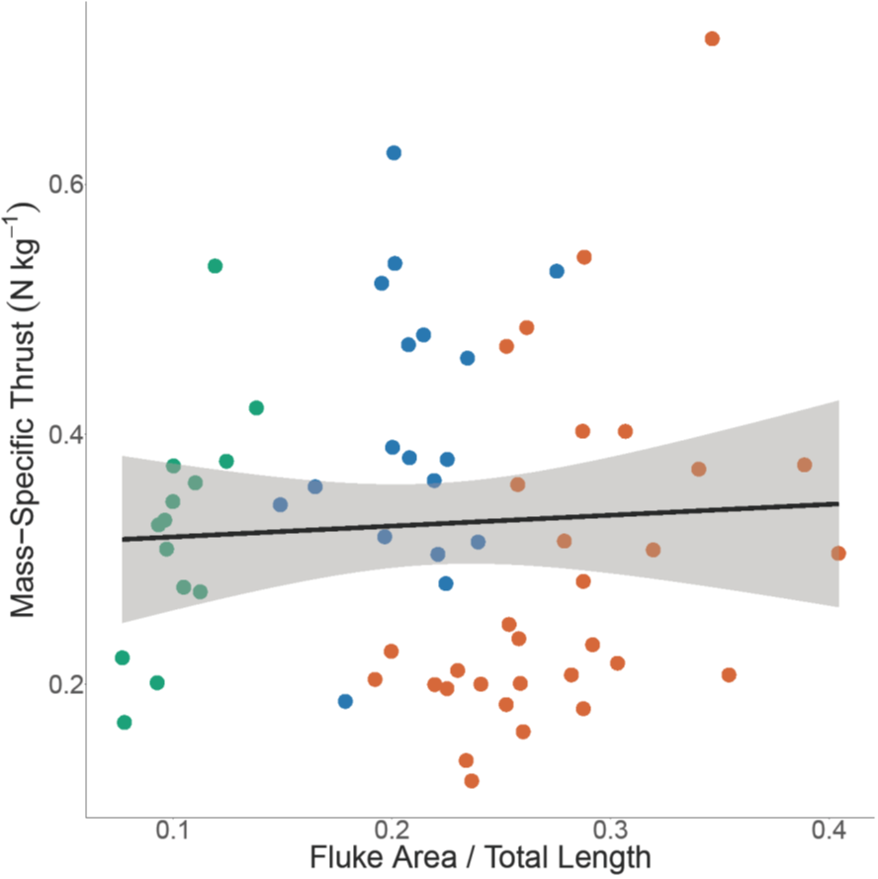

Figure 5. Linear regression of mass-specific thrust (N kg-1) versus the ratio of fluke area over total body length. Green, orange, and blue points correspond to minke, humpback, and blue whales.

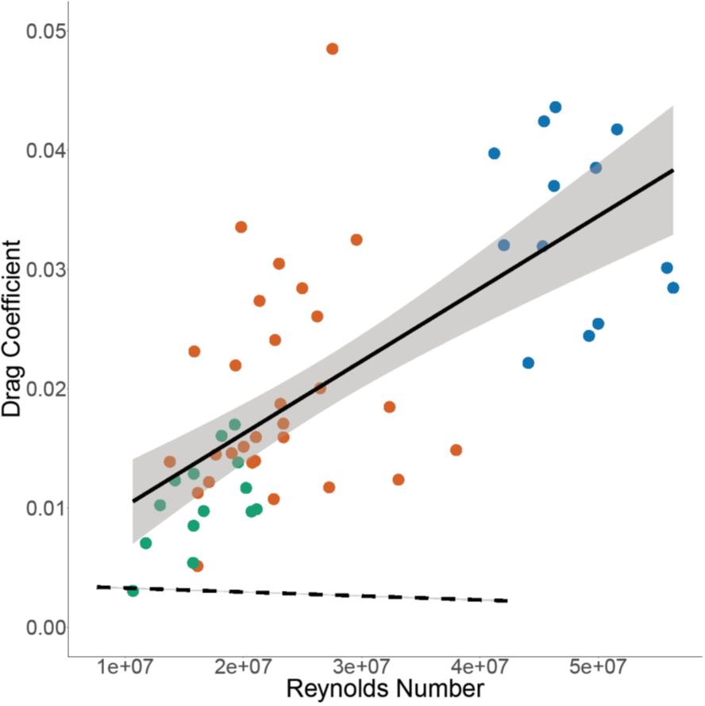

Figure 6. Linear regressions of drag coefficient versus Reynolds number for empirically-derived tag data (points and solid line) and a simple rigid-body model comparison using equations derived from Hoerner (1962) (dotted line). Green, orange, and blue points correspond to minke, humpback, and blue whales.

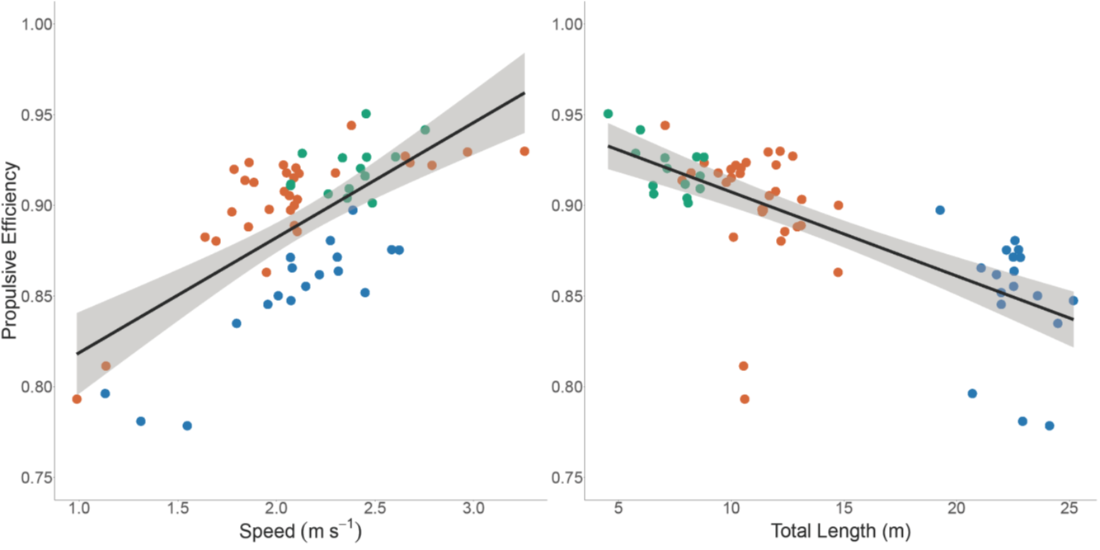

Figure 7. Linear regressions of propulsive efficiency versus swimming speed (m s-1) (left) and total body length (m) (right). Green, orange, and blue points correspond to minke, humpback, and blue whales.

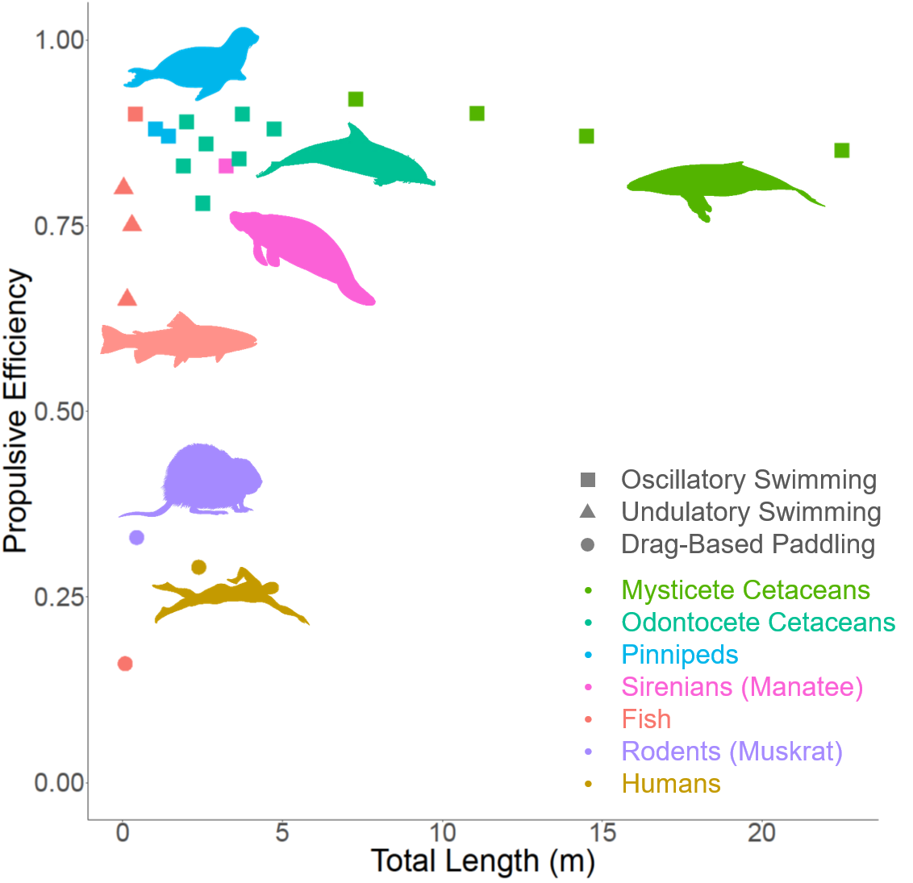

Figure 8. Propulsive efficiency versus total body length (m) for species from different morphological and taxonomic groups and which use different swimming modes. Three of the four mysticete cetaceans are the averaged species-level minke whale, humpback whale, and blue whale data from the present study. Silhouettes correspond to each group by rough position and color.